

Electronics Engineering Students’ Association (ELESA)

Presents

ELECTROVERT 2018

The Performers’ creed

Name of the Event: **Circuit-Tech (Expert )**

Candidate’s Code:

**Instructions**

* All **questions** are compulsory.
* All questions are compulsory and carries equal amount of marks.
* Use of calculators is allowed.
* Use of mobile is strictly prohibited

Date: **08 Sept 2018**

Time: **40 min**

Q1 *.Find iC2 (Si BJTs withβ1=*100 an dβ2*=50).*

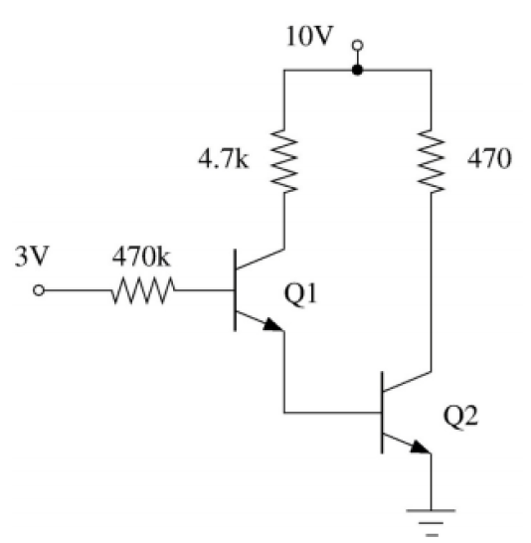

Q 2. Obtain the triangular wave at output if you are provided with sine wave as input, two op amps ,fixed voltage source, suitable resistors and capacitors,+Vcc ,-Vcc? Draw circuit diagram for your solution ?

Q3. A triangular voltage waveform Vi(t) is applied at the input to the circuit shown. Assume the diodes to be ideal.

1. Determine the output Vo(t)
2. Nearly sketch the output waveform superimposed on the input Vi(t) and label the key points.

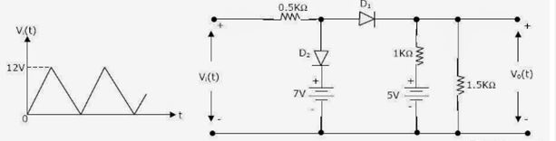

Q4.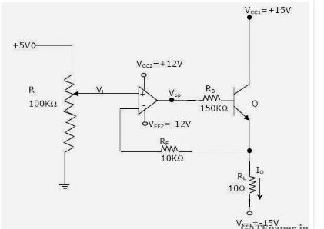

1. In which mode is the BJT operating (cut off /active/saturation) ?Justify your answer.
2. Obtain an expression relating the output current Io and the input voltage Vi.
3. Determine Io and Vop if Vi=2 Volts. Assume β=99, VBE=0.7 V